EEL 4930/5934 BioSignals Processing

Assignment 1- Due: September 11

Please write a report answering the following questions. Submit the report and all the m-files you used to answer the questions on Blackboard in Module Assignments / Assignment 1.

1. Write MATLAB code to
   1. Download, read and plot channel 1 only of the data file edbe0103.mat.
      1. What is the duration of the ECG signal in seconds?
      2. How is the length of the ECG signal in samples?
      3. What is the sampling rate?
   2. Find an estimate of the heart rate by measuring the duration between consecutive R waves. Save them in a vector called TH. First element of TH should be the distance between the first and second R waves, the second element of TH should be the distance between the second and third R waves and so on.
   3. Plot TH versus the given time vector tm (discard the last point of tm so that TH and tm are the same length).
   4. Find the mean and variance of TH.
   5. Comment on any observations, difficulties or aberrations you encounter.

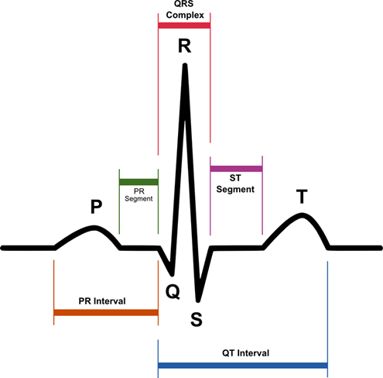

1. I WILL ADD MORE QUESTIONS AFTER THURSDAY 08/29.